Federal Agency Cloud Landing Zone
  - IPAM · SDN · DNS · PKI · Zero Trust — InfoBlox DDI Alignment to NIST, CISA, and FedRAMP
SSA Cloud Services Team
2026-06-29
Table of contents
Executive Summary 2
1 What Is a Federal Cloud Landing Zone? 3
1.1 SSA’s Multi-Cloud Landing Zone Scope 5
2 SDN and the End of Traditional DHCP 6
2.1 VMware NSX-T: DHCP Server Profiles and VCF 9.1 Native Integration 7
2.2 Microsoft Azure Government: The Fabric Replaces DHCP 8
2.3 AWS GovCloud: VPC DHCP Options and the Nitro Hypervisor 8
2.4 Oracle OCI: VCN DHCP Options and the VNIC Overlay 8
3 InfoBlox as the SDN-Aware IPAM Control Plane 9
3.1 What InfoBlox Provides That SDN Cannot 9
3.2 Microsoft Partnership: M365 GCC Endpoint Lifecycle 9
3.3 AWS Partnership: BloxOne Runs ON AWS GovCloud 12
3.4 Oracle Cloud / OCI: OPM HRIT Future Integration 13
4 Certificate Management and Cloud PKI Integration 14
4.1 The Certificate Lifecycle in a Multi-Cloud SDN Environment 15
4.2 Integration with Each Cloud Certificate Manager 15
5 NIST SP 800-53 Rev 5 Control Mapping 16
6 CISA Zero Trust Maturity Model v2.0 Alignment 18
6.1 Networks Pillar (Deepest Alignment) 18
6.2 Identity Pillar (Network-Layer Support) 19
6.3 Cross-Cutting: Visibility and Analytics 19
6.4 Cross-Cutting: Automation and Orchestration 20
7 FedRAMP Boundary Enforcement 20
8 FedRAMP Moderate and FedRAMP 20x Controls 22
8.1 FedRAMP Moderate: The Evidence Package 22
8.2 FedRAMP 20x: Automated KSI Enforcement 22
9 Inter-Agency SaaS Integration: The OPM HRIT Template 23
10 Architecture Summary 24
11 Recommended Buildout Roadmap 25
Phase 0 — Procurement and Architecture (Month 1) 25
Phase 1 — On-Premises Foundation (Months 1–3) 25
Phase 2 — VMware VCF 9.1 Integration (Months 2–4) 26
Phase 3 — Azure Government Integration (Months 3–5) 26
Phase 4 — AWS GovCloud Integration (Months 5–7) 26
Phase 5 — OCI OPM HRIT Integration (Months 7–9) 26
Phase 6 — FedRAMP Continuous Monitoring (Months 9–12) 27
References 27

Executive Summary
The Social Security Administration operates four distinct cloud environments — on-premises VMware Cloud Foundation, Microsoft Azure Government (GCC Moderate), AWS GovCloud, and Oracle Cloud Infrastructure (OCI) for OPM HRIT integration. Each environment uses a different Software Defined Networking fabric that replaces traditional broadcast DHCP with fabric-native IP assignment. Without a unified control layer, SSA has no cross-environment IP visibility, no unified DNS security policy, no automated certificate lifecycle, and must collect FedRAMP compliance evidence from four separate sources.
InfoBlox DDI — the market-leading platform for DNS, DHCP, and IP Address Management — solves all four problems from a single FedRAMP-authorized control plane (CSO FR2017257053, authorized January 2023, hosted on AWS GovCloud).
The three business outcomes this document demonstrates:
1. Operational Risk Elimination. A single Infoblox deployment replaces four separate DNS systems, four separate IP inventory processes, and four separate certificate-tracking tools. When a new cloud workload spins up in any environment, Infoblox automatically allocates an IP (cross-cloud conflict checked), creates DNS A and PTR records, and enrolls a machine certificate via SCEP — in seconds, without a change ticket. When a workload decommissions, all three are revoked atomically.
2. Continuous FedRAMP Compliance. Infoblox is the only DDI platform with its own FedRAMP Moderate CSO authorization, meaning SSA inherits the DDI layer controls rather than re-proving them. Evidence for SC-20/21 (DNSSEC), CM-8 (inventory), IA-5(2) (certificates), AU-12 (audit), and IR-4 (incident response) is generated continuously and automatically — not assembled manually for annual assessments.
3. M365 GCC Boundary Enforcement. Microsoft publishes M365 GCC endpoint changes up to 12 times per year. Without automation, each change requires four manual updates across NSG rules, VPC security groups, RPZ policies, and VPN split-tunnel configurations — during which a gap exists between when Microsoft changes an endpoint and when SSA’s controls reflect it. Infoblox polls the Microsoft 365 IP & URL Web Service API daily and pushes all four enforcement updates simultaneously, closing the boundary gap window to minutes.
Vendor relationships: InfoBlox has formal technology partnerships with all three of SSA’s primary cloud vendors. InfoBlox BloxOne’s own FedRAMP-authorized service runs on AWS GovCloud, making AWS the infrastructure foundation. InfoBlox is a Microsoft Azure Technology Alliance Partner with native Microsoft Sentinel, Defender Threat Intelligence, and Entra ID integrations. InfoBlox is available on the Oracle Cloud Marketplace with OCI connector support for the OPM HRIT integration path.
The recommendation is clear: procure InfoBlox DDI via the AWS GovCloud Marketplace (no separate IDIQ required), deploy Grid Members in each environment, and build the landing zone DNS and IPAM layer on InfoBlox from day one. Every workload deployed after that point inherits FedRAMP-compliant DNS, IP management, and certificate lifecycle automatically.

1 What Is a Federal Cloud Landing Zone?
A Cloud Landing Zone is the foundational, pre-configured environment that a federal agency provisions before any workload is deployed. It establishes the guardrails — network topology, identity controls, logging pipelines, encryption policies, and security baselines — that every subsequent workload inherits automatically.
For SSA operating under FedRAMP Moderate, the landing zone must satisfy four overlapping frameworks simultaneously:
- NIST SP 800-53 Rev 5 — the control catalog from which FedRAMP Moderate baselines are drawn
- CISA Zero Trust Maturity Model v2.0 — five pillars with three cross-cutting capabilities
- FedRAMP Moderate — boundary definition, continuous monitoring, evidence packaging
- FedRAMP 20x Consolidated Rules (2026) — automated, machine-readable compliance evidence enforced by infrastructure-as-code; Class A/B/C certification pipelines; mandatory January 1, 2027
 Important
FedRAMP 20x Consolidated Rules — June 25, 2026: FedRAMP published its Consolidated Rules for 2026 on June 25, 2026, transitioning 20x from pilot status to a fully available certification path with three classification tiers: Class A (opens August 3, 2026), Class B and C (open August 31, 2026). FedRAMP Ready submissions cease July 28, 2026. The Consolidated Rules become mandatory for all certified systems on January 1, 2027. Machine-readable structured rules are available in JSON format via GitHub for AI agent integration. InfoBlox DDI’s WAPI REST interface delivers machine-readable KSI evidence — the exact format the 20x framework requires — without manual assembly.

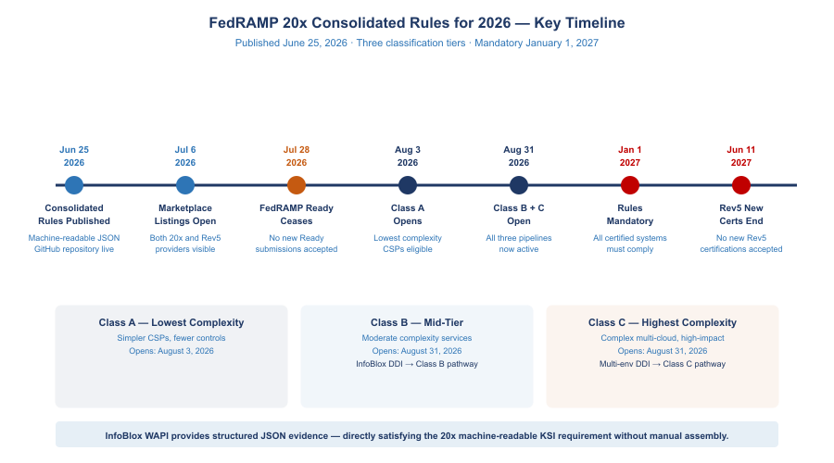
FedRAMP 20x Consolidated Rules for 2026 — Class Timelines and Key Dates
Important
The Core Insight: DNS, DHCP, and IP address management (DDI) are not optional infrastructure services — they are foundational security controls. Every device that joins a network, every cloud workload that provisions, every certificate that authenticates a service depends on DNS and IP assignment working correctly. A landing zone without unified DDI has a structural security gap at its foundation.

1.1 SSA’s Multi-Cloud Landing Zone Scope
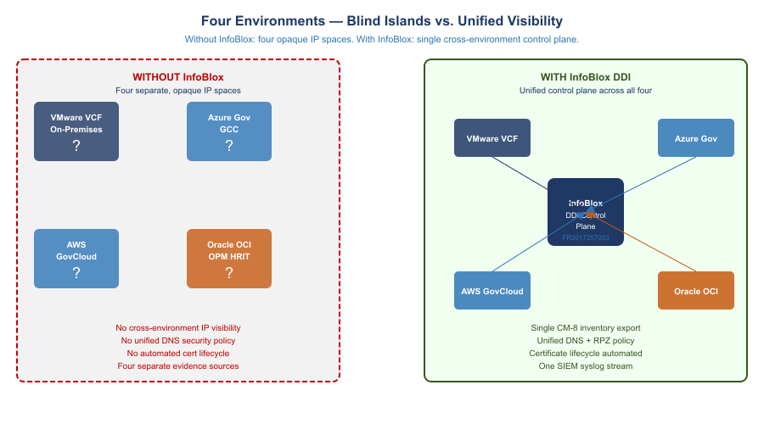
Four Environments — Blind Islands vs. Unified InfoBlox Visibility
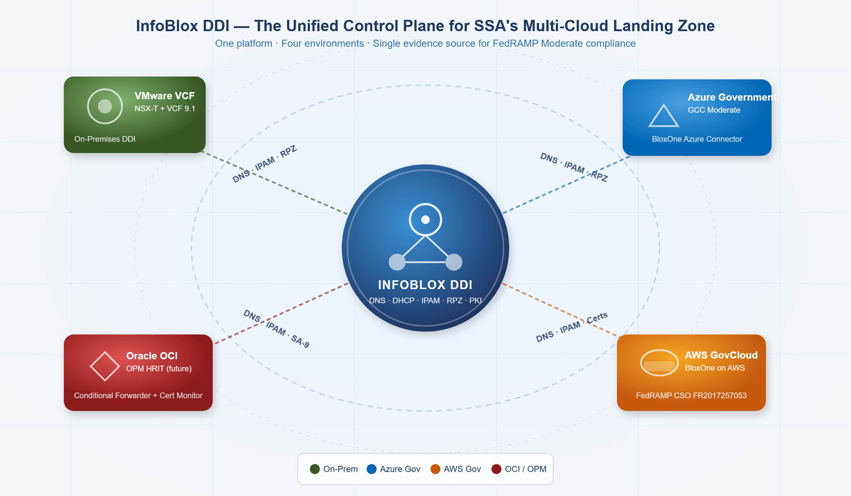
InfoBlox DDI as the Unified Control Plane for SSA’s Four-Environment Landing Zone
SSA’s landing zone spans four discrete cloud environments that must behave as a single logical security domain:
SSA Multi-Cloud Environments
Environment | Platform | SDN Technology | DHCP/IP Model | FedRAMP Boundary
On-Premises DC | VMware VCF / ESXi | NSX-T overlay (VXLAN/Geneve) | NSX-T DHCP Server Profiles on T1/T0 Gateways | Agency ATO
Azure Government GCC | Microsoft Azure | Azure VNet (SDN fabric, no broadcast) | Azure fabric assigns IPs; DHCP is abstracted away | Azure Government FedRAMP High
AWS GovCloud | Amazon AWS | VPC with ENI/Nitro hypervisor | VPC DHCP Options Sets; EC2 metadata service | AWS GovCloud FedRAMP High
Oracle Cloud OCI (OPM HRIT) | Oracle OCI | VCN with VNIC overlay | OCI DHCP options; instance metadata at 169.254.169.254 | OPM ATO (external)
The critical observation: none of these four environments uses traditional broadcast DHCP. Each uses a form of SDN where IP address assignment is managed by the hypervisor fabric — not a classic DHCP server. Without a unified IPAM overlay, these four IP spaces are opaque to each other and to SSA’s security operations center.

2 SDN and the End of Traditional DHCP
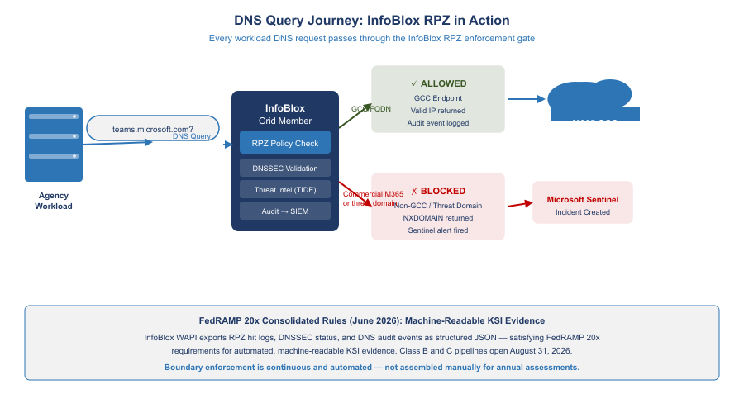
DNS Query Journey: InfoBlox RPZ Enforcement Gate
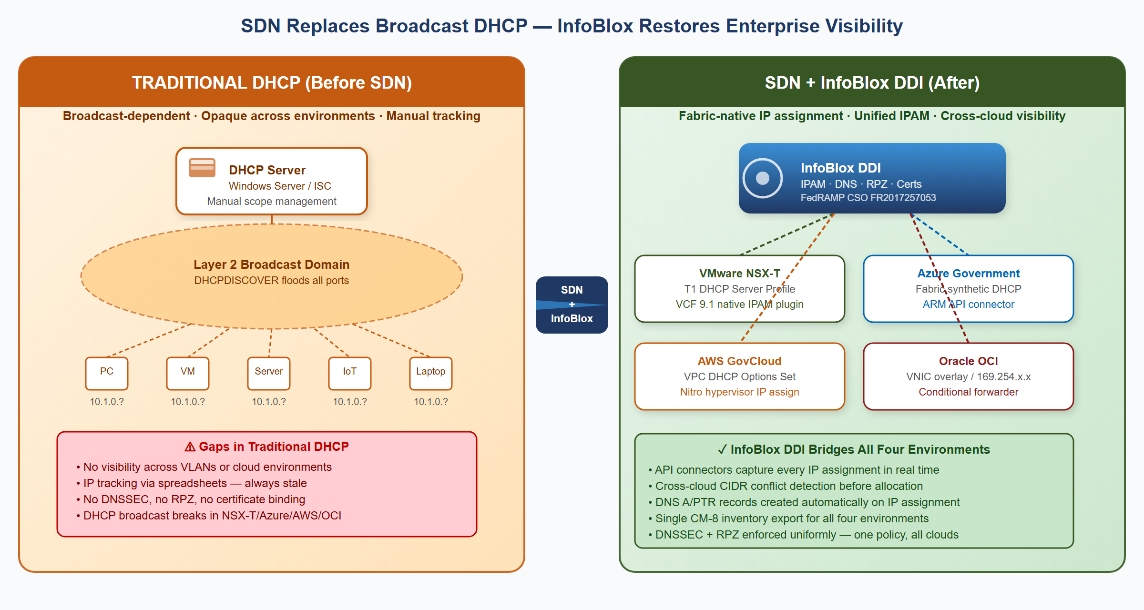
SDN Replaces Broadcast DHCP — InfoBlox Restores Enterprise Visibility
Traditional DHCP (RFC 2131) depends on Layer 2 broadcast. This model fundamentally breaks in Software Defined Networking environments because SDN uses overlay protocols (VXLAN, Geneve, STT) that operate at Layer 3 and suppress Layer 2 broadcasts by design.

2.1 VMware NSX-T: DHCP Server Profiles and VCF 9.1 Native Integration
VMware NSX-T replaces broadcast DHCP with DHCP Server Profiles attached to T1 Gateways. The NSX-T control plane intercepts DHCP requests at the logical switch level — the request never hits the physical network. Traditional DHCP servers are completely bypassed.
VMware Cloud Foundation 9.1 (released May 2026) introduced native InfoBlox DDI integration as a first-class feature:
- VCF Automation tenant requests a new network segment
- VCF background service calls InfoBlox NIOS WAPI or BloxOne REST API to reserve an IP block
- NSX-T creates the logical segment using the InfoBlox-allocated CIDR
- InfoBlox records the segment name, CIDR, VLAN/VNI, and tenant as extensible attributes
- When VMs deploy, NSX-T DHCP assigns IPs; InfoBlox receives assignments via the IPAM plugin
- DNS A/PTR records for each VM are created automatically — no manual DNS entry required
 Tip
VCF 9.1 Significance: Before VCF 9.1, NSX-T InfoBlox integration required custom scripts and manual configuration. VCF 9.1 makes InfoBlox the native, default IPAM backend for VMware Cloud Foundation — meaning every new VCF deployment at SSA can have InfoBlox IPAM built in from day one.

2.2 Microsoft Azure Government: The Fabric Replaces DHCP
Azure Virtual Networks do not use DHCP in the traditional sense. When a VM is deployed, the Azure hypervisor fabric directly assigns the IP — the VM receives the IP via a synthetic DHCP response injected by the Azure host agent. There is no DHCP broadcast.
Azure reserves five IP addresses in every subnet that cannot be assigned (x.x.x.0 network, x.x.x.1 gateway, x.x.x.2–3 Azure DNS, x.x.x.255 broadcast). Beyond these, IP assignment is managed entirely by the Azure control plane.
InfoBlox’s Azure connector continuously pulls VNet subnet configurations and VM NIC IP assignments via the Azure Resource Manager API, writing every Azure IP into the Azure-GCC Network View in the InfoBlox IPAM database.

2.3 AWS GovCloud: VPC DHCP Options and the Nitro Hypervisor
AWS VPCs use DHCP Options Sets to specify DNS servers and domain names, but the actual IP assignment is managed by the AWS Nitro hypervisor — not a traditional DHCP server. EC2 instances receive IPs via a synthetic DHCP interaction at the VPC CIDR +2 address.
Replacing the default AmazonProvidedDNS with the InfoBlox Grid Member IP in the VPC DHCP Options Set directs all EC2 DNS queries through the enterprise RPZ and DNSSEC validation layer. InfoBlox’s AWS connector syncs EC2 instance IP assignments, subnet CIDRs, and VPC IPAM pool allocations into the AWS-GovCloud Network View.

2.4 Oracle OCI: VCN DHCP Options and the VNIC Overlay
OCI uses Virtual Network Interface Cards (VNICs) inside Virtual Cloud Networks. OCI’s internal DHCP implementation is fabric-native — the OCI hypervisor responds to DHCP requests on behalf of each subnet from the metadata service at 169.254.169.254.
For OPM HRIT, SSA cannot control OCI DHCP Options because OPM manages the tenancy. However, SSA can document all known OPM HRIT service IPs as external host records in InfoBlox (read-only OCI Network View) and configure conditional forwarders for OPM HRIT FQDNs routing through the FastConnect path.

3 InfoBlox as the SDN-Aware IPAM Control Plane
InfoBlox DDI operates as a control plane over SDN environments — not replacing the SDN fabric’s internal IP assignment mechanisms, but serving as the authoritative record and policy engine above them.

3.1 What InfoBlox Provides That SDN Cannot
InfoBlox Value-Add Over Native SDN
Capability | What SDN Platforms Provide | What InfoBlox Adds
IP assignment | Per-environment only | Cross-cloud conflict detection before allocation
DNS | Per-environment resolver | Authoritative + recursive with DNSSEC, unified across all four
DHCP inventory | Per-VPC/VNet/segment dashboard | Single CM-8-ready inventory spanning all environments
Certificate management | None / per-CA | Certificate Tracker links cert to IP host record, expiry alerts
Threat blocking | Per-environment (DNS Firewall, NSG) | Single RPZ policy propagated to all Grid Members in seconds
Audit logging | Per-environment log silo | Single syslog stream to SIEM, AU-12 evidence
IaC integration | Per-cloud provider only | Terraform InfoBlox provider works across all environments

3.2 Microsoft Partnership: M365 GCC Endpoint Lifecycle
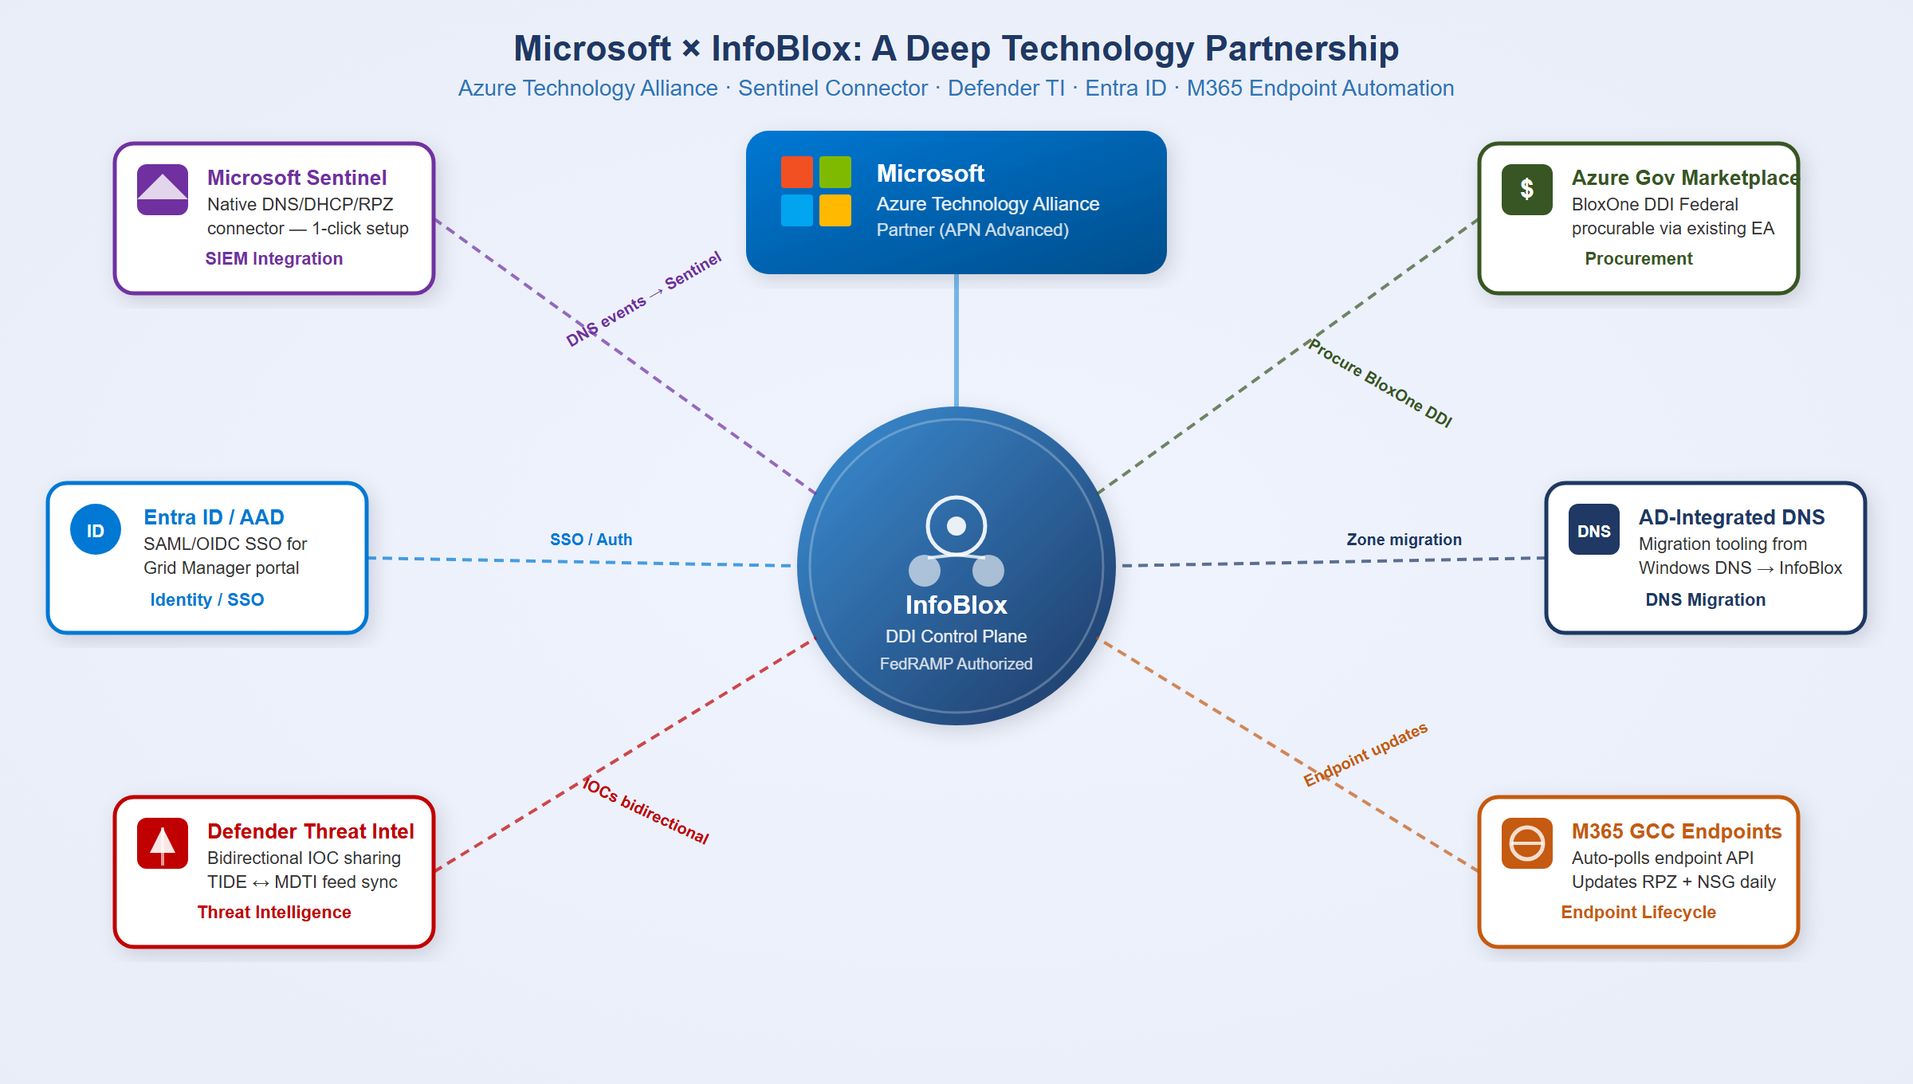
Microsoft × InfoBlox Technology Partnership — Six Integration Points
InfoBlox and Microsoft have a formal Azure Technology Alliance Partnership with six distinct integration points:
Microsoft-InfoBlox Integration Points
Integration | What It Does
Microsoft Sentinel Native Connector | First-party Sentinel content pack — DNS Security Events, DHCP events, RPZ blocks stream to Sentinel without custom parsing
Defender Threat Intelligence (MDTI) | Bidirectional IOC sharing between InfoBlox TIDE and MDTI — a domain blocked by MDTI is also blocked by InfoBlox RPZ
Entra ID / Azure AD SSO | InfoBlox Grid Manager and BloxOne portal support Entra ID SAML/OIDC — Grid admin auth governed by SSA Conditional Access policies
Azure Government Marketplace | BloxOne DDI Federal is procurable via existing Azure EA/ELA agreements — no separate IDIQ
AD-Integrated DNS Migration | Documented migration tooling from Windows DNS zones to InfoBlox Grid — AD still replicates, InfoBlox serves authoritative records
M365 GCC Endpoint Lifecycle | InfoBlox polls Microsoft 365 IP & URL Web Service API and auto-updates all enforcement layers

3.2.1 M365 GCC Boundary Enforcement
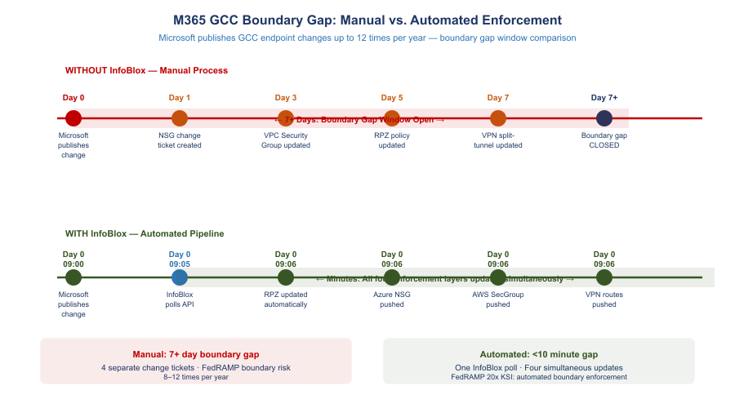
M365 GCC Boundary Gap: Manual vs. Automated Enforcement
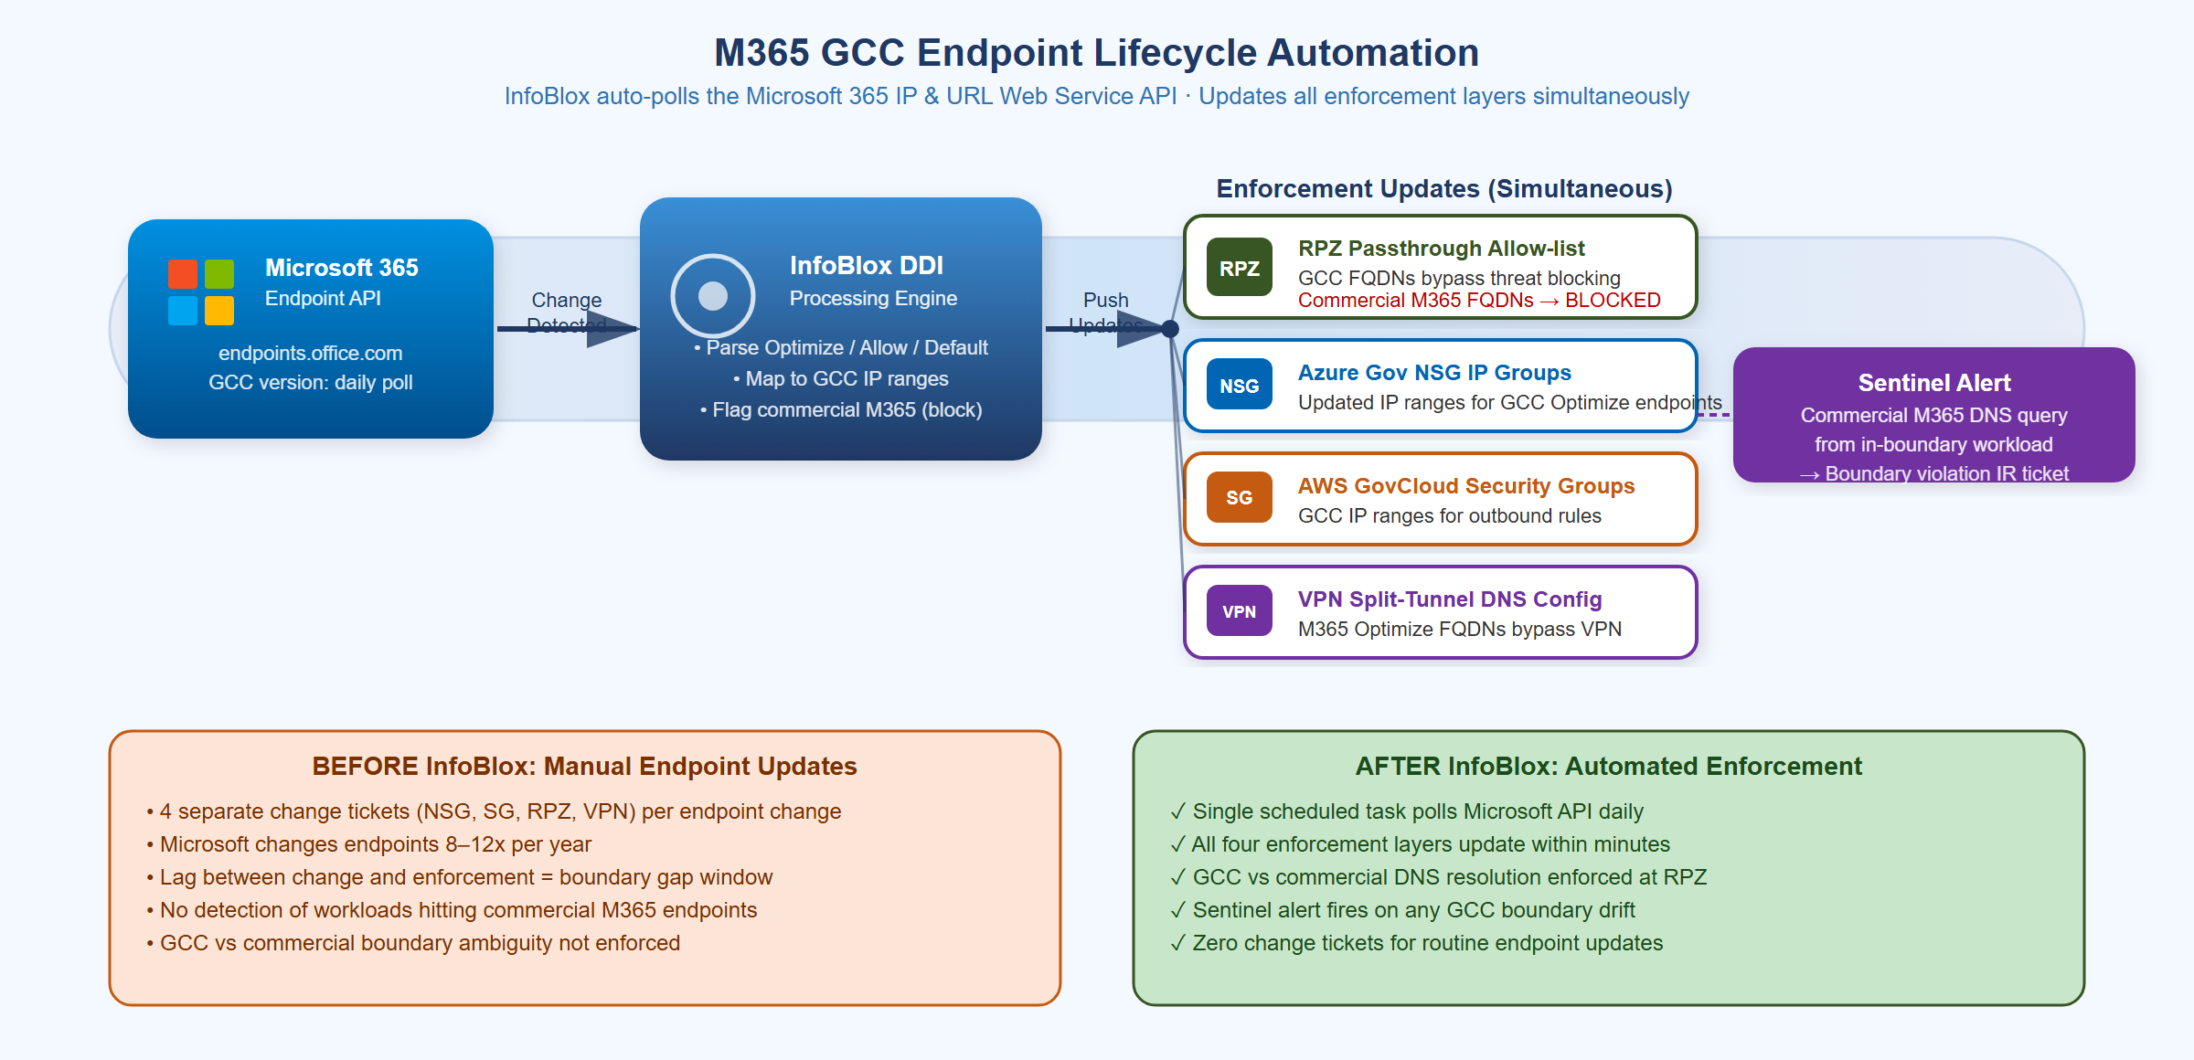
M365 GCC Endpoint Lifecycle Automation — One Poll, Four Enforcement Updates
Microsoft publishes M365 endpoint changes (IP ranges + FQDNs) via the Office 365 IP and URL Web Service API. For GCC Moderate specifically, Microsoft publishes a separate GCC endpoint list — the commercial and GCC IP ranges are different and must not be mixed. A workstation accidentally reaching a commercial Microsoft 365 endpoint instead of the GCC endpoint is a FedRAMP boundary violation.
InfoBlox provides the automated enforcement pipeline:
- Daily poll of the Microsoft M365 GCC endpoint API (version-change detection)
- RPZ passthrough allow-list — GCC FQDNs explicitly allowed through threat blocking
- RPZ block list — commercial M365 FQDNs (non-GCC) blocked at DNS layer
- Azure NSG IP Group update — GCC Optimize IP ranges pushed to Azure Government
- AWS GovCloud Security Group update — GCC IP ranges for outbound rules
- VPN split-tunnel DNS — M365 Optimize FQDNs route via local interface, not VPN tunnel
- Sentinel alert — any DNS query from an in-boundary workload to a commercial M365 endpoint triggers an IR ticket
 Warning
Without InfoBlox automation: Each of Microsoft’s 8–12 annual endpoint changes requires four separate change tickets across NSG, Security Groups, RPZ, and VPN config — during which SSA has a boundary gap window. With InfoBlox, all four update within minutes of Microsoft’s API publishing the change.

3.3 AWS Partnership: BloxOne Runs ON AWS GovCloud
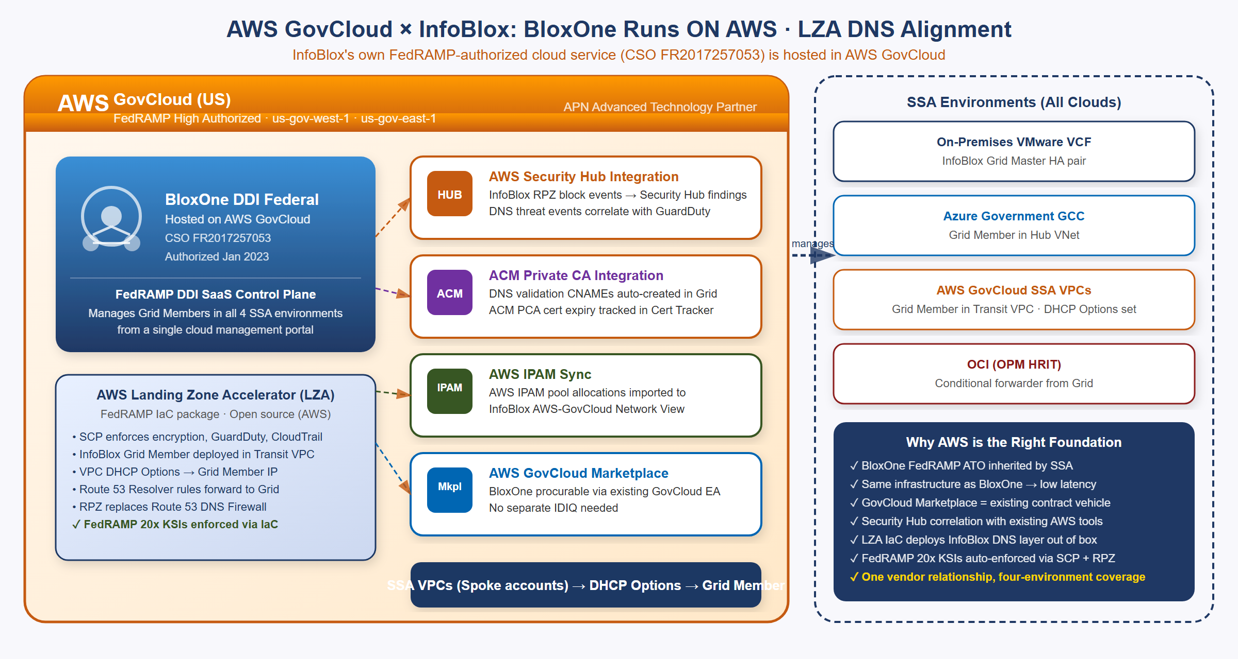
AWS GovCloud × InfoBlox — BloxOne DDI Federal Hosted on AWS, LZA DNS Alignment
The AWS relationship is the deepest of all three cloud vendors: InfoBlox’s own FedRAMP-authorized cloud service (BloxOne DDI Federal, CSO FR2017257053) is hosted on AWS GovCloud. This makes AWS the infrastructure foundation for InfoBlox’s SaaS control plane.
Tip
Key Point: When SSA uses BloxOne DDI Federal, the control plane is hosted on AWS GovCloud infrastructure with its own FedRAMP High authorization. SSA inherits both the InfoBlox DDI CSO (FR2017257053) and the AWS GovCloud infrastructure authorization — layered FedRAMP coverage.

AWS-specific InfoBlox capabilities:
- AWS Landing Zone Accelerator (LZA) Integration: LZA is the AWS-published IaC package for FedRAMP-compliant landing zones. InfoBlox integrates as the DNS customization layer, replacing the default Route 53 Resolver-only DNS with Grid Member + RPZ + DNSSEC. FedRAMP 20x KSIs are enforced via SCP + InfoBlox RPZ policy.
- AWS Security Hub: InfoBlox RPZ block events flow natively to Security Hub findings and correlate with GuardDuty detections.
- ACM Private CA Integration: InfoBlox auto-creates DNS validation CNAME records for ACM certificate issuance; ACM PCA certificate expiry is tracked in InfoBlox Certificate Tracker.
- AWS IPAM Sync: AWS IPAM pool allocations are imported into InfoBlox’s AWS-GovCloud Network View — cross-cloud CIDR conflict detection includes native AWS IPAM-managed ranges.
- AWS GovCloud Marketplace Procurement: BloxOne DDI Federal is procurable via the GovCloud Marketplace against existing EA agreements — no separate IDIQ or procurement action required.
 Note
Route 53 Private Zone DNSSEC Gap: AWS Route 53 private hosted zones cannot be DNSSEC-signed — this is a documented AWS platform limitation as of 2026. InfoBlox Grid Members sign all internal zones including private SDN segments, closing this gap. This is a key differentiator for FedRAMP SC-20/SC-21 evidence.

3.4 Oracle Cloud / OCI: OPM HRIT Future Integration
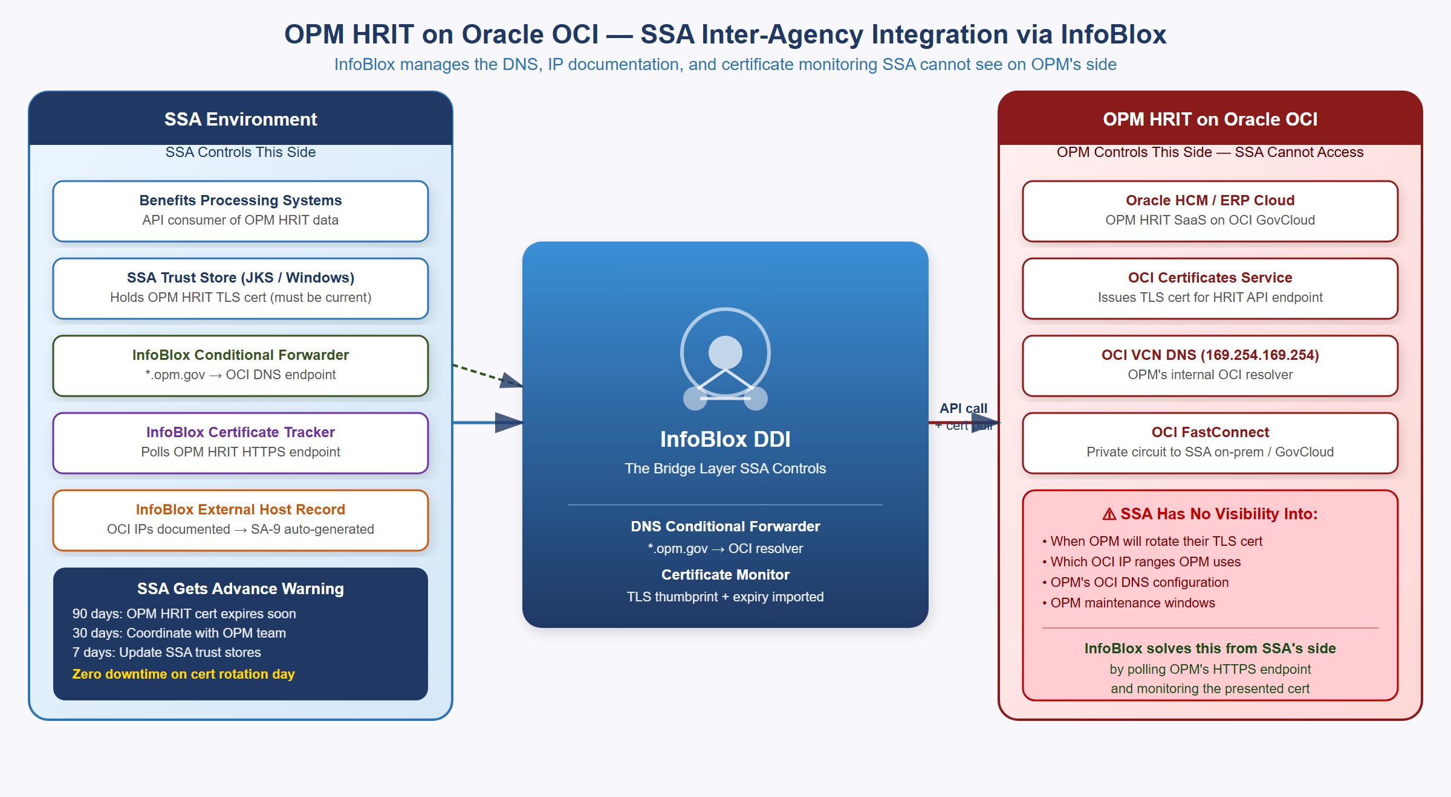
OPM HRIT on Oracle OCI — SSA Inter-Agency Integration via InfoBlox Certificate Monitor
OPM is migrating HRIT (federal HR and benefits processing) to Oracle HCM Cloud on OCI. As OPM’s HRIT moves to OCI-hosted SaaS, SSA’s integration path changes from a mainframe handoff to a cloud API call from SSA’s environment to OPM’s OCI-hosted service endpoints.
The challenge: OPM controls their OCI tenancy. SSA has no visibility into OPM’s certificate rotation schedule, IP range changes, or maintenance windows. When OPM rotates their HRIT API TLS certificate without SSA’s trust stores being updated, the HRIT API call fails — personnel action feeds stop, benefits enrollment breaks.
InfoBlox manages SSA’s side of the integration:
OPM HRIT Integration via InfoBlox
Integration Layer | InfoBlox Capability
DNS resolution | Conditional forwarder: *.opm.gov → OCI DNS endpoint; InfoBlox resolves from SSA network
IP documentation | OPM HRIT OCI IPs imported as external host records (read-only OCI Network View); SA-9 table auto-generated
Certificate monitoring | InfoBlox Certificate Tracker polls OPM HRIT HTTPS endpoints; captures TLS cert thumbprint + expiry
Expiry alerting | 90/30/7-day alerts give SSA advance notice of OPM cert rotation
Trust store prep | New OPM cert thumbprint pre-staged in InfoBlox before rotation day — zero-downtime update

Important
The OPM HRIT Pattern Repeats: OPM HRIT on OCI is the first of many federal inter-agency SaaS integrations (OPM, DHS, IRS, VA are all moving shared services to cloud SaaS). InfoBlox gives SSA the monitoring layer it needs for every inter-agency dependency: conditional DNS forwarders, Certificate Tracker, and external host records — from SSA’s side, without requiring API access to the partner agency’s cloud tenancy.

4 Certificate Management and Cloud PKI Integration
Software Defined Networking eliminates IP address broadcasts but creates a new requirement: in an SDN environment where workloads are ephemeral and IPs change frequently, every service-to-service call must be mutually authenticated with certificates. Certificate subject names (CN and SAN fields) must match DNS names registered in the DNS system — which InfoBlox manages. InfoBlox is therefore the natural integration point for certificate lifecycle management.
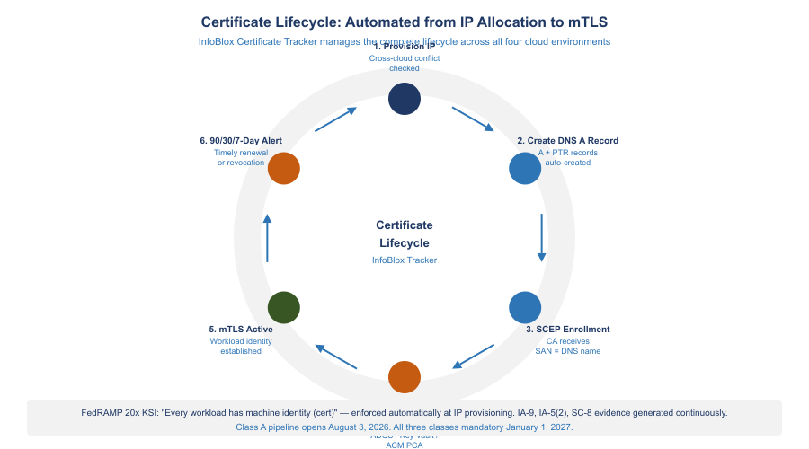
Certificate Lifecycle: Automated from IP Allocation to mTLS

4.1 The Certificate Lifecycle in a Multi-Cloud SDN Environment
The complete certificate lifecycle for a cloud workload follows this sequence:
- VM or container provisioned by VCF Automation, Terraform, or cloud-native IaC
- InfoBlox IPAM allocates an IP from the correct Network View (cross-cloud conflict-checked)
- InfoBlox Grid automatically creates a DNS A record: workload-name.environment.agency.gov → IP
- Workload bootstrap sends SCEP or EST enrollment to the agency CA using the DNS name as the certificate SAN
- CA (ADCS, Azure Key Vault with SCEP, AWS ACM Private CA) issues a certificate binding the SAN to the workload
- InfoBlox Certificate Tracker receives the certificate thumbprint, expiry, and issuing CA, binding it to the IP host record
- mTLS is active: the workload presents the certificate to authenticate to other services
- 90/30/7 days before expiry, InfoBlox Certificate Tracker generates alerts for timely renewal

4.2 Integration with Each Cloud Certificate Manager
Certificate Manager Integrations
Platform | Integration Method | InfoBlox Role
ADCS (On-Prem) | SCEP/EST connector; InfoBlox SCEP auto-enrollment | Triggers enrollment on IP host record creation; binds cert thumbprint to IP record
Azure Key Vault (GCC) | Azure Key Vault REST API polling | Imports cert metadata; correlates cert to Azure VM NIC IP; alerts on expiry
AWS ACM Private CA | ACM API; DNS validation CNAME auto-creation | Creates ACM validation CNAMEs in Grid; tracks ACM PCA cert expiry
Oracle OCI Certificates | HTTPS endpoint polling (no OCI API needed) | Imports OPM HRIT endpoint cert thumbprint; 90/30/7-day alerts to SSA team
Keyfactor / Sectigo CLM | Bidirectional API integration | InfoBlox as DNS name SSOT for cert SAN validation; CLM uses InfoBlox IP ranges for discovery scanning

Tip
Zero Trust Enabler: Certificate-to-IP binding in InfoBlox is the technical foundation of ‘never trust, always verify’ at the network layer. When every IP host record carries a certificate thumbprint and expiry date, the network infrastructure itself becomes identity-aware — a core requirement of CISA’s Zero Trust Maturity Model Networks pillar at Advanced/Optimal level.

5 NIST SP 800-53 Rev 5 Control Mapping
The following table maps InfoBlox DDI landing zone capabilities to specific NIST SP 800-53 Rev 5 controls. A single InfoBlox deployment provides evidence for 16 controls that would otherwise require separate evidence collection from four separate platforms.
NIST SP 800-53 Rev 5 Control Coverage
Control | What InfoBlox DDI Provides | Evidence Artifact | Satisfies
SC-20 | DNSSEC signing of all DNS zones including internal SDN segments | DNSSEC key log; DS record at .gov registrar | SC-20, SC-20(1)
SC-21 | Recursive DNSSEC validation on all Grid Members; RPZ with CISA Protective DNS feed | RPZ hit log → SIEM; validation failure alert | SC-21
SC-22 | Network Insight auto-generates DDI topology; Grid Master-to-Member map | Network Insight export; SSP Appendix J | SC-22
SC-7 | RPZ enforces domain-level egress blocking across all four SDN environments; DNS exfiltration detection | RPZ block rate dashboard; exfil alert config | SC-7, SC-7(7)
SC-8 | mTLS between workloads via certificate-to-IP binding; SCEP/EST enrollment before service traffic | Certificate Tracker report; mTLS config | SC-8, SC-8(1)
CM-8 | Every IP host record = CM-8 inventory item; SDN connector enriches with VM name, OS, owner, cloud region | IP host record export to ServiceNow CMDB | CM-8, CM-8(1)
CM-2 | IaC integration creates IP+DNS+cert records atomically and destroys them on decommission | Terraform state; IP lifecycle audit log | CM-2, CM-6
SA-9 | External DNS registered as governed external services; all forwarded queries logged; OPM HRIT documented | Forwarder config export; SSP SA-9 table | SA-9
IA-5(2) | Certificate Tracker links cert thumbprint+expiry+issuer to IP host record; ADCS/Key Vault/ACM/OCI cert metadata | Cert inventory report; expiry alert log | IA-5(2)
IA-9 | Every SDN workload receives a certificate via SCEP/EST automation at provisioning time | SCEP enrollment log; cert-to-IP binding report | IA-9
AU-2 | DNS query events, DHCP lease events, IP allocation events, and cert enrollment events defined and logged | SIEM event catalog; AU-2 event list | AU-2
AU-12 | Single syslog stream from all Grid Members across all four SDN environments; RFC 5424 format; 3-year retention | SIEM dashboards; retention policy | AU-12
IR-4 | RPZ block events auto-generate SIEM IR tickets; DNSSEC failure triggers SOC alerts; DNS exfil detection | IR playbook; RPZ alert→ticket pipeline | IR-4, IR-5
SI-3 | DNS-layer malware blocking via RPZ prevents resolution of C2 domains, ransomware, phishing | RPZ block count by threat category | SI-3, SI-3(1)
PL-8 | Unified DDI architecture in SSP; InfoBlox FedRAMP ATO cited as inherited control for DDI layer | SSP Section 13 architecture narrative | PL-8

6 CISA Zero Trust Maturity Model v2.0 Alignment
CISA’s Zero Trust Maturity Model v2.0 (April 2023) defines five pillars and three cross-cutting capabilities across four maturity stages: Traditional → Initial → Advanced → Optimal.
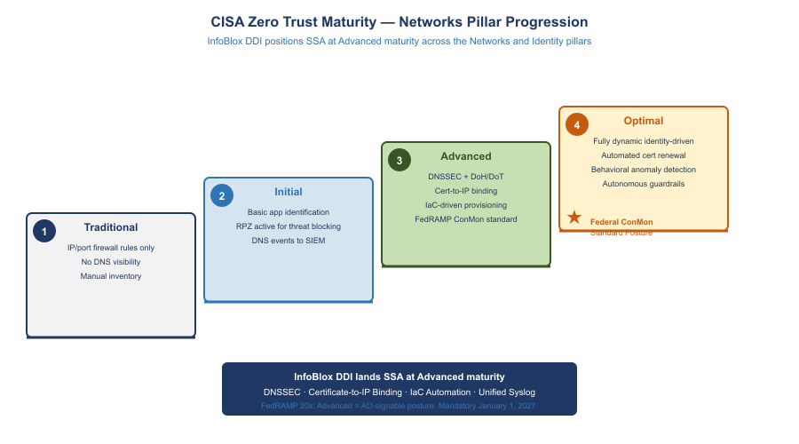
CISA Zero Trust Maturity — Networks Pillar Progression

6.1 Networks Pillar (Deepest Alignment)
CISA Zero Trust Networks Pillar Alignment
CISA ZT Network Requirement | InfoBlox DDI Implementation | ZT Maturity Level
Encrypt DNS traffic (DoH/DoT) | Grid Members support DoH/DoT for client queries; DNSSEC validates response integrity end-to-end | Advanced → Optimal
Implement Protective DNS | RPZ with CISA Protective DNS feed + TIDE commercial threat intel; blocks C2, phishing, DNS tunneling across all SDN environments | Initial → Advanced
DNS visibility for all workloads | Unified syslog from all Grid Members; every DNS query logged with client IP, query name, response, latency | Initial → Advanced
IPAM as segmentation enforcement | Network Views enforce CIDR segregation; IaC cannot allocate overlapping CIDRs; segment-level records map to NSX-T security groups and Azure NSGs | Advanced
SDN micro-segmentation integration | NSX-T security groups can reference InfoBlox IPAM tags (workload classification, owner) as dynamic membership criteria | Advanced → Optimal
Certificate-based network authentication | Certificate Tracker ensures every IP host record has a bound certificate; IP reputation replaced by certificate identity | Advanced → Optimal

6.2 Identity Pillar (Network-Layer Support)
InfoBlox supports the Identity pillar through certificate lifecycle management — the mechanism by which workload identity is established at the network layer:
- SCEP/EST automation issues certificates to every new workload at provisioning time, establishing machine identity before the first connection
- Certificate-to-IP binding enables network devices to verify workload identity from the DNS/IPAM layer without agent deployment
- Certificate expiry alerting prevents identity credential expiration — a common cause of authentication outages

6.3 Cross-Cutting: Visibility and Analytics
InfoBlox contributes three telemetry streams to CISA’s Visibility and Analytics capability:
- DNS query telemetry: every DNS resolution event from every SDN workload, with client IP, query type, response, latency, and RPZ action
- DHCP/IP event telemetry: every IP allocation, renewal, and release with device metadata
- Certificate telemetry: every expiry warning and enrollment event
All three streams flow to the SIEM in consistent syslog format — enabling correlation across DNS, IP, and certificate events that individually appear innocuous but together may indicate lateral movement or data exfiltration.

6.4 Cross-Cutting: Automation and Orchestration
InfoBlox’s IaC integrations directly enable the CISA Automation and Orchestration capability:
- Network resource provisioning (IP, DNS, cert) is automated in IaC pipelines — no manual steps that bypass policy
- VCF 9.1 native InfoBlox integration automates DDI for VMware workloads from day one
- RPZ updates are automated from threat intelligence feeds — human review required only for false positive exceptions

7 FedRAMP Boundary Enforcement
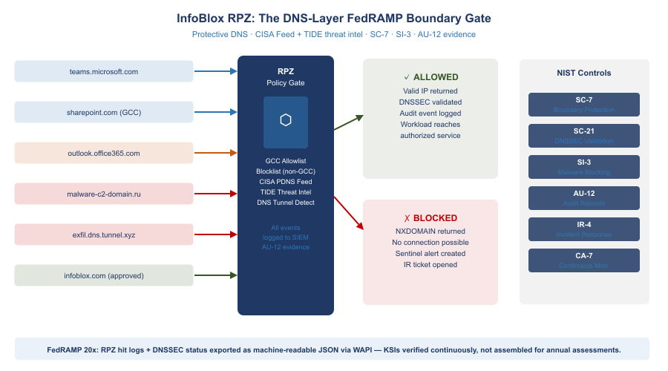
InfoBlox RPZ: The DNS-Layer FedRAMP Boundary Gate
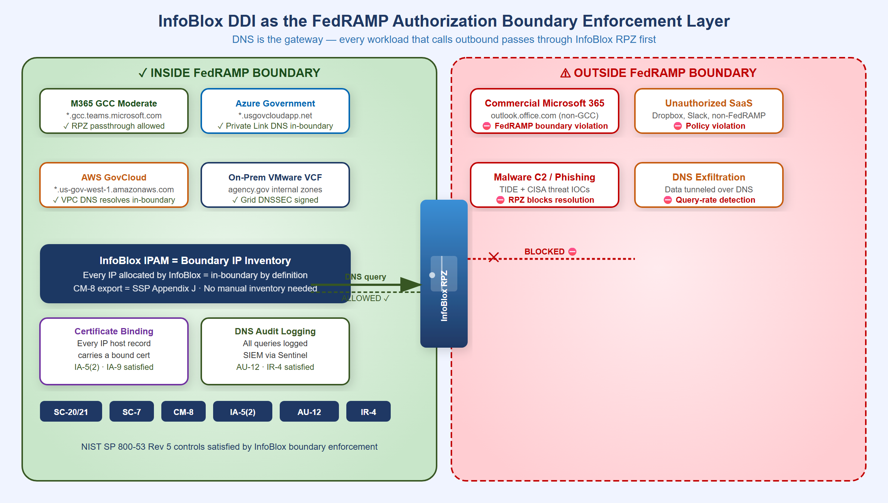
InfoBlox DDI as the FedRAMP Authorization Boundary Enforcement Layer
InfoBlox DDI enforces the FedRAMP authorization boundary at three layers simultaneously:
Layer 1 — IP Inventory = Boundary Definition. The FedRAMP authorization boundary is defined by IP address ranges. InfoBlox IPAM is the authoritative record of every IP inside the boundary. The CM-8 IP inventory export is the boundary IP list — no separate reconciliation required.
Layer 2 — DNS = Boundary Enforcement at Egress. Every DNS query from every workload passes through the InfoBlox Grid Member (because all VPC/VNet/NSX-T DHCP Options point to it). InfoBlox enforces:
- RPZ blocks commercial M365 endpoints (prevents FedRAMP data reaching non-GCC Microsoft infrastructure)
- RPZ blocks non-FedRAMP SaaS FQDNs (prevents workloads from reaching unauthorized cloud services)
- Conditional forwarders for external services generate the SA-9 documentation automatically
- DNSSEC validation required — DNS spoofing that could redirect traffic outside the boundary is rejected
- Query logging for all workloads — AU-12 evidence: every external communication visible in DNS logs
Layer 3 — Certificate Binding = Boundary Identity. Only IP host records within the InfoBlox IPAM database can receive certificates via SCEP/EST enrollment automation. Certificate possession = boundary membership — a powerful assertion for boundary documentation and IA-9 satisfaction.

8 FedRAMP Moderate and FedRAMP 20x Controls

8.1 FedRAMP Moderate: The Evidence Package
InfoBlox DDI produces a complete evidence package for FedRAMP Moderate annual assessments without manual evidence collection:
FedRAMP Moderate Evidence Package
Control Family | Evidence Source | Format | Collection
SC-20 / SC-21 | InfoBlox DNSSEC key rotation log; RPZ hit log | Grid audit log export | Automated
CM-8 | InfoBlox IP host record database | CSV / ServiceNow CMDB sync | API export on demand
IA-5(2) | InfoBlox Certificate Tracker | Certificate inventory report | API export on demand
AU-2 / AU-12 | SIEM fed by InfoBlox syslog stream | SIEM query results | Pre-built SIEM dashboards
IR-4 | SIEM IR playbook execution logs; RPZ alert ticket history | ServiceNow tickets | ITSM integration
SA-9 | InfoBlox External DNS Server config; SSP SA-9 table | InfoBlox config export | Grid config snapshot
SC-22 | InfoBlox Network Insight topology report | PDF / JSON topology export | Network Insight scheduler

8.2 FedRAMP 20x: Automated KSI Enforcement
FedRAMP published its Consolidated Rules for 2026 on June 25, 2026, establishing a single stable ruleset that supersedes the 20x pilot framework. Three classification tiers replace the single 20x path: Class A (simplest CSPs, opens August 3, 2026), Class B and Class C (open August 31, 2026). The Consolidated Rules become mandatory for all certified systems on January 1, 2027. New Rev5 certifications will no longer be accepted after June 11, 2027. Machine-readable rules are published in JSON format via GitHub, enabling AI agent integration and automated compliance verification.
For SSA’s multi-environment landing zone, InfoBlox DDI is well-positioned for the Class B or Class C pathway given its multi-cloud scope. The WAPI REST interface delivers structured JSON evidence for every KSI — no manual assembly required.
FedRAMP 20x replaces periodic evidence collection with continuously-verified Key Security Indicators enforced by infrastructure-as-code guardrails:
FedRAMP 20x KSI Automation
FedRAMP 20x KSI | InfoBlox Enforcement | Automated?
All DNS traffic encrypted or integrity-protected | DNSSEC on all zones; DoH/DoT endpoint on Grid Members | Yes — Grid policy
Protective DNS for all workloads | Grid Member = resolver for all VPC/VNet DHCP options; RPZ active | Yes — DHCP Options + RPZ
IP address inventory current and complete | API connectors sync in near-real-time; CM-8 report on demand | Yes — API connectors
No CIDR overlap between environments | Terraform InfoBlox provider blocks overlapping allocation at request time | Yes — Terraform
Certificate expiry monitored and auto-renewed | Certificate Tracker 90/30/7-day alerts; SCEP/EST auto-renewal workflow | Yes — Certificate Tracker
Every workload has machine identity (cert) | SCEP/EST enrollment triggered at IP host record creation | Yes — Auto-enrollment
DNS change events auditable | All DNS/DHCP/IP changes logged; syslog to SIEM in real time | Yes — Syslog + SIEM

Tip
FedRAMP 20x Positioning: InfoBlox DDI positions SSA ahead of the FedRAMP 20x transition. The machine-readable IP inventory (WAPI), automated KSI enforcement via IaC, and real-time SIEM integration align directly with FedRAMP 20x’s shift from periodic assessment to continuous automated verification.

9 Inter-Agency SaaS Integration: The OPM HRIT Template
OPM HRIT on OCI is the first of many federal inter-agency SaaS integrations. OPM, SSA, DHS, IRS, and VA are all moving shared services to cloud-hosted SaaS platforms. The pattern repeats every time:
- Agency A moves a shared service to cloud SaaS (OPM HRIT → OCI)
- Agency B (SSA) becomes an API consumer of that SaaS
- Agency B has no visibility into Agency A’s certificate rotation, endpoint changes, or IP range changes
- InfoBlox gives Agency B the monitoring layer it needs — from SSA’s side, without requiring access to the partner agency’s cloud
InfoBlox’s inter-agency integration toolkit:
- Conditional DNS forwarders — always know where the service resolves, even when the partner agency changes DNS
- Certificate Tracker endpoint polling — always know when the partner’s TLS cert will expire
- External host records — always document the partner’s IP ranges for SA-9 without API access to their cloud
- RPZ passthrough entries — ensure InfoBlox RPZ does not block the inter-agency API calls
- Sentinel alerts — detect if the inter-agency connection’s certificate has changed unexpectedly (potential MITM)

10 Architecture Summary
Full Landing Zone Architecture Summary
Layer | On-Premises VMware | Azure Government | AWS GovCloud | Oracle OCI (OPM) | InfoBlox Role
IP Assignment | NSX-T DHCP Profiles (VCF 9.1) | Azure fabric / ARM API | VPC DHCP Options / Nitro | OCI VNIC / 169.254.169.254 | IPAM SSOT via connectors
DNS Resolver | Grid Member (replaces AD DNS) | Azure DNS Private Resolver → Grid | VPC DHCP Options → Grid | OCI resolver → Grid forwarder | Unified recursive + DNSSEC
DNS Authority | Grid Master (agency.gov) | Grid Member + Azure Private DNS | Grid Member + Route 53 private | Grid forwarder + OCI DNS | Grid Master as SSOT
DHCP | InfoBlox Grid DHCP (HA pair) | Azure fabric (no Grid DHCP) | AWS VPC DHCP | OCI DHCP | On-prem native; cloud via API
IPAM | On-Premises Network View | Azure-GCC Network View | AWS-GovCloud Network View | OCI-OPM Network View (RO) | Single DB, 4 Network Views
Certificates | ADCS via SCEP/EST | Azure Key Vault; ARM API polling | ACM Private CA; validation CNAMEs | OCI Certs (OPM); cert polling | Certificate Tracker
Threat / RPZ | RPZ on Grid Members; TIDE + CISA | RPZ on Azure Grid Member | RPZ on AWS Grid Member | Grid forwarder RPZ | Single policy, all environments
Audit / SIEM | Syslog from Grid Members | Syslog from Azure Grid Member | Syslog from AWS Grid Member | Syslog from Grid forwarder | One syslog stream
FedRAMP Controls | SC-20/21, CM-8, AU-12, IR-4 | SC-20/21, SA-9, IA-5(2), CM-8 | SC-20/21, SA-9, IA-5(2), CM-8 | SA-9, IA-5(2) | Single evidence source

11 Recommended Buildout Roadmap
Each phase produces immediately usable compliance evidence and security value — there is no ‘big bang’ dependency before the first phase delivers results.
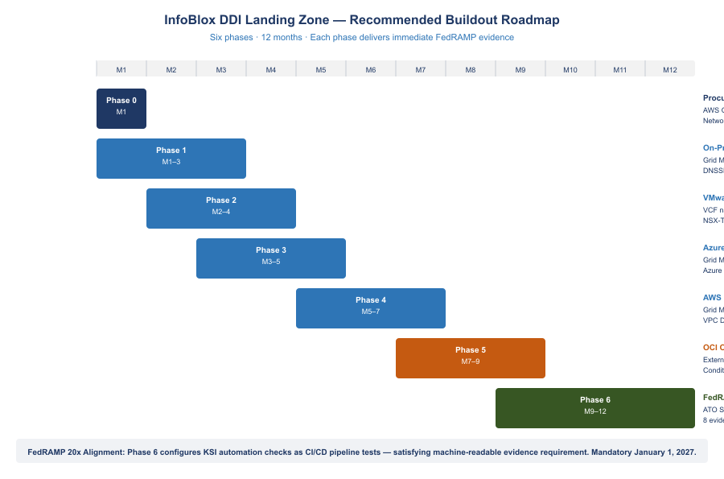
InfoBlox DDI Landing Zone — Six-Phase Buildout Roadmap

Phase 0 — Procurement and Architecture (Month 1)
- Procure InfoBlox BloxOne DDI Federal via AWS GovCloud Marketplace against existing EA (no new IDIQ)
- Reference FedRAMP Marketplace CSO FR2017257053 in procurement documentation
- Design Network View CIDR allocation plan: audit all existing IP ranges across on-prem, Azure VNet, AWS VPC, OCI VCN for overlaps
- Engage InfoBlox Professional Services for VCF 9.1 DDI integration workshop

Phase 1 — On-Premises Foundation (Months 1–3)
- Deploy Grid Master HA pair; import all AD DNS zones; enable DNSSEC for agency.gov
- Submit DS record to .gov TLD registrar (closes SC-20 gap)
- Migrate Windows Server DHCP scopes to InfoBlox Grid DHCP; enable DHCP fingerprinting
- Configure syslog forwarding from all Grid Members to SIEM (Splunk/Sentinel); verify AU-12 event receipt
- Deploy SCEP connector to ADCS; test automated cert enrollment from new IP host record
- Generate first CM-8 IP inventory export; reconcile against existing CMDB

Phase 2 — VMware VCF 9.1 Integration (Months 2–4)
- Update VCF to 9.1; configure VCF-A to use InfoBlox WAPI as external IPAM backend
- Update NSX-T DHCP Server Profiles to route DNS to InfoBlox Grid Member IP
- Verify NSX-T VM IP assignments appear in InfoBlox On-Premises Network View within 60 seconds

Phase 3 — Azure Government Integration (Months 3–5)
- Deploy InfoBlox Grid Member as Azure VM in Hub VNet; configure Azure DNS Private Resolver to forward to Grid Member
- Register all Azure VNet/subnet CIDRs in InfoBlox Azure-GCC Network View; enable Azure connector
- Configure Azure Key Vault Certificate Manager polling in InfoBlox Certificate Tracker
- Configure M365 GCC endpoint API polling; test RPZ passthrough and commercial M365 RPZ block

Phase 4 — AWS GovCloud Integration (Months 5–7)
- Deploy InfoBlox Grid Member as EC2 instance in Transit VPC
- Update VPC DHCP Options Sets to use Grid Member IP as domain-name-server
- Enable InfoBlox AWS connector; register all VPC CIDR allocations in AWS-GovCloud Network View
- Configure ACM DNS validation CNAME automation; test certificate issuance for an internal ALB
- Integrate InfoBlox RPZ events with AWS Security Hub findings

Phase 5 — OCI OPM HRIT Integration (Months 7–9)
- Import all known OPM HRIT service endpoint IPs and FQDNs as external host records
- Configure InfoBlox conditional forwarder for OPM HRIT FQDNs through FastConnect path
- Connect InfoBlox Certificate Tracker to OPM HRIT HTTPS endpoints; verify 90-day cert expiry alert fires
- Document OCI integration in SSP SA-9 external services table with OPM as system owner

Phase 6 — FedRAMP Continuous Monitoring (Months 9–12)
- Complete InfoBlox FedRAMP ATO documentation in SSP; reference CSO FR2017257053 for DDI layer control inheritance
- Configure all eight FedRAMP control evidence exports as scheduled reports
- Implement IaC Terraform pipeline: IP allocation → DNS record → SCEP cert enrollment as single atomic pipeline
- Configure FedRAMP 20x KSI automation checks (DNSSEC status, RPZ coverage, cert expiry, CIDR conflict) as CI/CD pipeline tests

References
References
Source | URL
InfoBlox FedRAMP Marketplace (CSO FR2017257053) | fedramp.gov/marketplace/products/FR2017257053
VMware VCF 9.1 InfoBlox DDI Integration (May 2026) | blogs.vmware.com/cloud-foundation
Register InfoBlox NIOS DDI with NSX — Broadcom TechDocs | techdocs.broadcom.com/…/integrate-nsx-with-infoblox
Microsoft 365 IP and URL Web Service | docs.microsoft.com/en-us/microsoft-365/enterprise/microsoft-365-ip-web-service
AWS VPC IP Address Manager (IPAM) | docs.aws.amazon.com/vpc/latest/ipam
Azure Virtual Network Manager IPAM (preview) | learn.microsoft.com/en-us/azure/virtual-network-manager/concept-ip-address-management
CISA Zero Trust Maturity Model v2.0 (April 2023) | cisa.gov/sites/default/files/2023-04/zero_trust_maturity_model_v2_508.pdf
FedRAMP 20x KSI Enforcement — AWS Public Sector | aws.amazon.com/blogs/publicsector/preventive-controls-for-fedramp-20x
InfoBlox NIOS 9.0 Certificate Management | docs.infoblox.com/space/nios90/280266962
AWS Landing Zone Accelerator on AWS (LZA) | github.com/awslabs/landing-zone-accelerator-on-aws
InfoBlox IPAM and DHCP Solutions | infoblox.com/solutions/ipam-dhcp
Configure DHCP for Azure VMware Solution (NSX-T) | learn.microsoft.com/en-us/azure/azure-vmware/configure-dhcp-azure-vmware-solution

